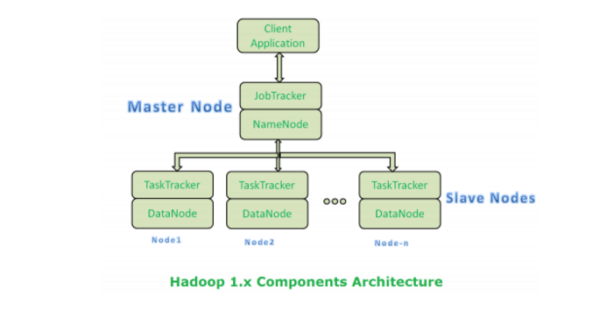

**How Store and Compute Operations Work in Hadoop:**

All these Master Node and Slave Nodes are organized into a Network of clusters. Each Cluster is again divided into Racks. Each rack contains a set of Nodes (Commodity Computer).

When Hadoop system receives “Store” operation like storing Large DataSets into HDFS, it stores that data into 3 different Nodes (As we configure Replication Factor = 3 by default). This complete data is not stored in one single node. Large Data File is divided into manageable and meaningful Blocks and distributed into different nodes with 3 copies.

If Hadoop system receives any “Compute” operation, it will talk to near-by nodes to retrieve those blocks of Data. While Reading Data or Computing if one or more nodes get failed, then it will automatically pick-up performing those tasks by approaching any near-by and available node.